Preparation of Full Paper for ICONSAD’23
Author^{*,1}, Author¹, Author²

*e-mail address, ORCID: 0000-0000-0000-0000
¹Department name of organization1, Name of organization1, City, Country
²Department name of organization2, Name of organization2, City, Country

Abstract: Abstracts must be included in the submitted papers. The abstract should be prepared in Times New Roman font with 12 pt. There should no nonstandard abbreviations, acknowledgments of support, references or footnotes in the abstract. The abstract should include the purpose, method, findings and results information and information about the study. Abstract title should be written in bold and within the paragraph. "Keywords:" should be written in italic, 12 pt., with no line space after the abstract. Each word of keywords must begin with a capital letter.

Keywords: ….

INTRODUCTION
This document is a template for Microsoft Word versions 6.0 or later. If you are reading a paper or PDF version of this document, please download the electronic file from the ICONSAD web site at www.iconsad.org so you can use it to prepare your manuscript.
Do not change the font sizes or line spacing to squeeze more text into a limited number of pages. Use italics for emphasis; do not underline. Please observe the conference page limits.

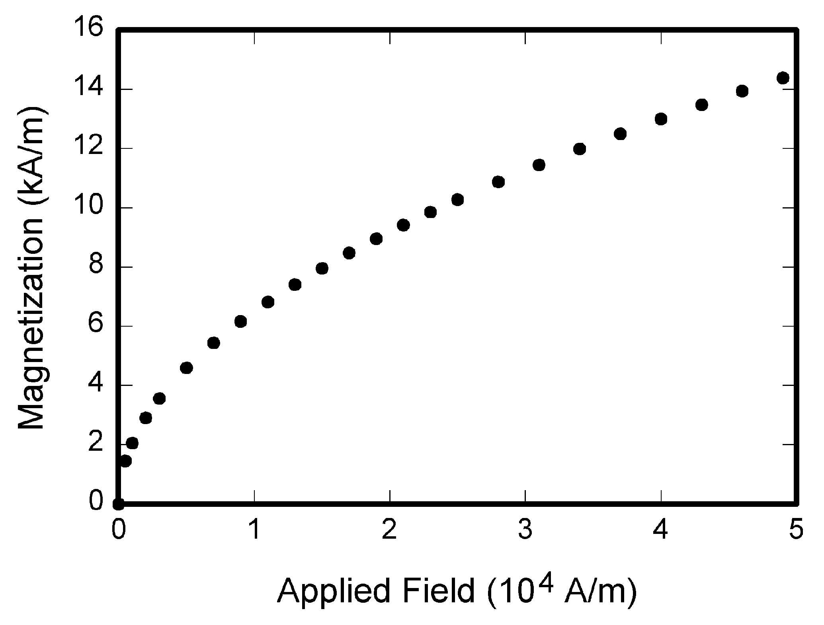
Fig. 1. Magnetization as a function of applied field. Note that “Fig.” is abbreviated. There is a period after the figure number, followed by two spaces. It is good practice to explain the significance of the figure in the caption.

References
This abstract may include references. Citations will be numbered consecutively within brackets [1]. The sentence punctuation follows the bracket [2]. Refer simply to the reference number, as in [3] — do not use “Ref. [3]” or “reference [3]” except at the beginning of a sentence: “Reference [3] was the first ...”
Unless there are six authors or more give all authors’ names; do not use “et al.”. Papers that have not been published, even if they have been submitted for publication, should be cited as “unpublished” [4]. Papers that have been accepted for publication should be cited as “in press” [5]. Capitalize only the first word in a paper title, except for proper nouns and element symbols.
For papers published in translation journals, please give the English citation first, followed by the original foreign-language citation [6].

Abbreviations and Acronyms
Define abbreviations and acronyms the first time they are used in the text, even after they have already been defined in the abstract. Abbreviations such as IEEE, SI, ac, and dc do not have to be defined. Abbreviations that incorporate periods should not have spaces: write “C.N.R.S.,” not “C. N. R. S.” Do not use abbreviations in the title unless they are unavoidable

Table I Units for Magnetic Properties
Sym | Quantity | Conversion from Gaussian and  CGS EMU to SI ª
Φ | magnetic flux | 1 Mx → 10⁻⁸ Wb = 10⁻⁸ V·s
B | magnetic flux density, magnetic induction | 1 G → 10⁻⁴ T = 10⁻⁴ Wb/m²
H | magnetic field strength | 1 Oe → 10³/(4π) A/m
m | magnetic moment | 1 erg/G = 1 emu → 10⁻³ A·m² = 10⁻³ J/T
M | magnetization | 1 erg/(G·cm³) = 1 emu/cm³ → 10³ A/m
4πM | magnetization | 1 G → 10³/(4π) A/m
σ | specific magnetization | 1 erg/(G·g) = 1 emu/g → 1 A·m²/kg
j | magnetic dipole moment | 1 erg/G = 1 emu → 4π × 10⁻¹⁰ Wb·m
J | magnetic polarization | 1 erg/(G·cm³) = 1 emu/cm³ → 4π × 10⁻⁴ T
χ, κ | susceptibility | 1 → 4π
χ_{ρ} | mass susceptibility | 1 cm³/g → 4π × 10⁻³ m³/kg
μ | permeability | 1 → 4π × 10⁻⁷ H/m = 4π × 10⁻⁷ Wb/(A·m)
μ_{r} | relative permeability | μ → μ_{r}
w, W | energy density | 1 erg/cm³ → 10⁻¹ J/m³
N, D | demagnetizing factor | 1 → 1/(4π)

CONCLUSION
Please include a brief summary of the possible clinical implications of your work in the conclusion section. Although a conclusion may review the main points of the paper, do not replicate the abstract as the conclusion. Consider elaborating on the translational importance of the work or suggest applications and extensions.

APPENDIX
Appendixes, if needed, appear before the acknowledgment.

ACKNOWLEDGMENT
The preferred spelling of the word “acknowledgment” in American English is without an “e”
after the “g.” Use the singular heading even if you have many acknowledgments. Avoid expressions such as “One of us (S.B.A.) would like to thank ... .” Instead, write “F. A. Author thanks ... .” Sponsor and financial support acknowledgments are placed in the unnumbered footnote on the first page, not here.

REFEENCES
[1] G. Eason, B. Noble, and I.N. Sneddon, “On certain integrals of Lipschitz-Hankel type involving products of Bessel functions,” Phil. Trans. Roy. Soc. London, vol. A247, pp. 529-551, April 1955.
[2] J. Clerk Maxwell, A Treatise on Electricity and Magnetism, 3rd ed., vol. 2. Oxford: Clarendon, 1892, pp.68-73.
[3] I.S. Jacobs and C.P. Bean, “Fine particles, thin films and exchange anisotropy,” in Magnetism, vol. III, G.T. Rado and H. Suhl, Eds. New York: Academic, 1963, pp. 271-350.
[4] K. Elissa, “Title of paper if known,” unpublished.
[5] R. Nicole, “Title of paper with only first word capitalized,” J. Name Stand. Abbrev., in press.
[6] Y. Yorozu, M. Hirano, K. Oka, and Y. Tagawa, “Electron spectroscopy studies on magneto-optical media and plastic substrate interface,” IEEE Transl. J. Magn. Japan, vol. 2, pp. 740-741, August 1987 [Digests 9th Annual Conf. Magnetics Japan, p. 301, 1982].
[7] M. Young, The Technical Writer’s Handbook. Mill Valley, CA: University Science, 1989.

